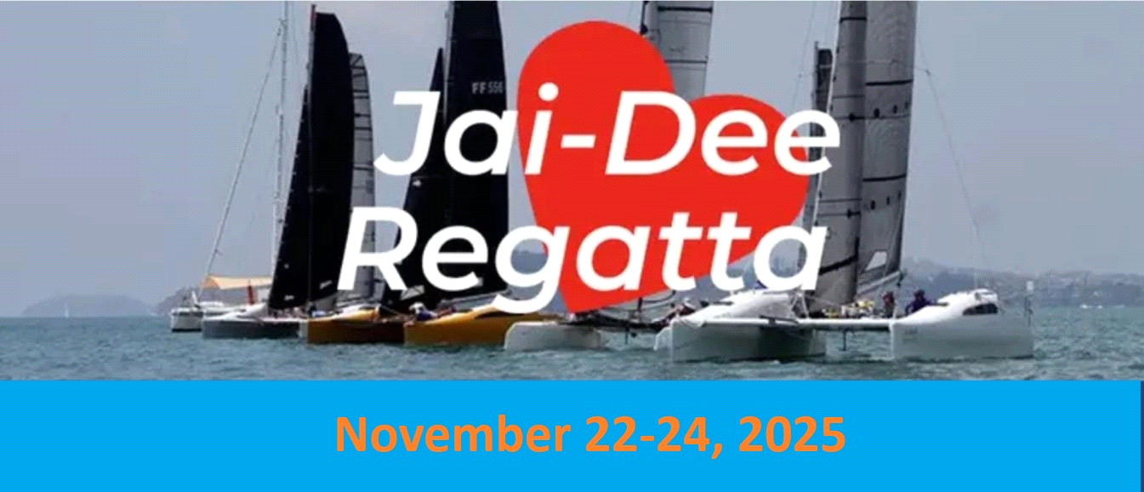

PRELIMINARY NOTICE OF RACE
Organising Authority - The Regatta is organised by the Phuket Yacht Club (PYC)

Rules
1 The regatta will be governed by the rules as defined in The Racing Rules of Sailing and by:
2. The Firefly 850 Sports One Design Class Rules,
3. Other O.D. classes considered acceptable by the organizers, Phuket Yacht Club
4. This Notice of Race and the Sailing Instructions
5. In case of conflict, the Sailing Instructions will prevail (this changes RRS Rule 63.7).
6. World Sailing Offshore (OSR) Special Regulations for Inshore Racing in daylight hours
shall apply to all boats except that: the requirement to be self-righting will not apply;
and lifelines will not be required.
7. All boats shall carry an operational marine band VHF radio and monitor the
designated channels from 30 minutes before any scheduled start until after
finishing.
8. No national prescriptions will apply.

Eligibility and Entry
1. The Regatta is open to all mono and multihulls with a length overall of greater than 6
meters that are acceptable to the Race Committee.
2. The Regatta will receive entries from One Design classes (subject to entries
received) and under the handicap system specified in brackets below.
Class 1 - Racing Monohull (IRC)
Class 2 - Racing Multihull (OMR)
Class 3 - Performance Handicap Monohull
Class 4 - Performance Handicap Multihull

3. The Race Committee may change the above eligibility factors and number of
classes based on its analysis of entries received. A minimum of 4 boats are
required to constitute a class or division, however exemptions may be made at
the races committee’s discretion.

Application for entry shall be made on the official Entry Form, which are available at
PYC and online from this site. Entries should be submitted online at
www.phuketyachtclub.com Entries may be made up until close of registration at 19:00
hrs. Friday the 21st of November 2025 Entry Fee for all classes – Members THB 8,000 per boat Non-Members 10,000 Baht

Schedule of Events:

The following is the proposed schedule:
Friday November 21st – Registration / weigh-in
17:00-19:00

November 22nd Race Day #1 Up to 3 races scheduled
Briefing 9:30
First warning signal 11:00

Sunday November 23rd Race Day #2 Up to 3 races scheduled
First Warning Signal 11:00

Monday November 24th Race Day #3 Up to 3 races scheduled
First Warning Signal 11:00
Prize giving ceremony 17:30
Buffet Dinner 18:00

Sailing Instructions
The Sailing Instructions will be available at registration.
Courses
1. Racing will take place in or in the environs of Ao Chalong.
2. Courses will be chosen to take into account prevailing or forecast conditions for each
race.
3. Windward/leeward courses will be located in Ao Chalong.
4. Coastal courses may take place around islands, fixed navigation marks and inflatable buoys in and around the environs of Ao Chalong.
5. Course diagrams will be displayed at the briefing.

Penalty System

1. For all classes, rule 44.1 is changed so that the Two-Turns Penalty is replaced by the
One-Turn Penalty.
2. Decisions of the protest committee will be final as provided in rule 70.5.

SCORING
1. For all classes, a maximum of 9 races are scheduled.
2. Two completed races are required to constitute a series.
3. All races count towards points, there are no discarded races
CREW WEIGHT
1. Firefly 850 Sports One Design
2. Platu 25
In accordance with class rules.

RADIO COMMUNICATION ꢀ
Except in an emergency, a boat shall neither make radio transmissions while racing nor
receive radio communications not available to all boats. This restriction also applies to
mobile telephones. Race committee will be using Channel 72 for all regatta communications.

PRIZES
Prizes will be awarded to the top three yachts in each class.
INSPECTION
All yachts shall be liable for inspection in accordance with applicable safety and
measurement requirements.
INSURANCE
Each participating boat shall be insured with valid third party liability insurance to a minimum
cover of Thai Baht Ten Million (or equivalent) for the duration of the event.
DISCLAIMER
Competitors participate in the regatta entirely at their own risk. See rule 4, Decision to Race.
The organizing authority will not accept any liability for material damage or personal injury
or death sustained in conjunction with or prior to, during, or after the regatta.
FURTHER INFORMATION
For further information please check www.phuketyachtclub.com.

